BTEC MEDIA UNIT 1 EXAM REVISION PACK
- Analogue: Devices which record data linearly from one point to another. Analogue devices read the media, such as tapes or records, by scanning the physical data off the media.
    - Clocks with hands
    - VCRs
    - Cameras with film
    - Cassette Tapes
- Digital: Devices which perform all calculations using ones and zeroes. This method of computing is referred to as the "binary system“. Digitized information is recorded in binary code of combinations of the digits 0 and 1, also called bits, which represent words and images. Digital technology enables immense amounts of information to be compressed on small storage devices that can be easily preserved and transported.
    - Digital Cameras
    - CDs/DVDs
    - iPods
    - Computers
- Sectors: An area or portion of the media that is distinct from others (i.e. filmmaking, audio, publishing, games, websites, etc.).
- Digital Media Platforms: A digital way for media to be distributed and accessed. Digital distribution includes TV broadcasts, pay-per-view, theatrical/cinema release, digital download, radio broadcasts, DVDs, CDs. It can also include online content such as webpages and streaming. Devices used to access digital media include:
    - mobile phones, PCs, laptops, MP3 players, MP4 players, games consoles and handheld devices, radio and tablets.
The main media sectors include:
- Moving Image: Film, Television
- Audio: Radio, Music
- Publishing: Magazines, e-Mags
- Websites
- Gaming

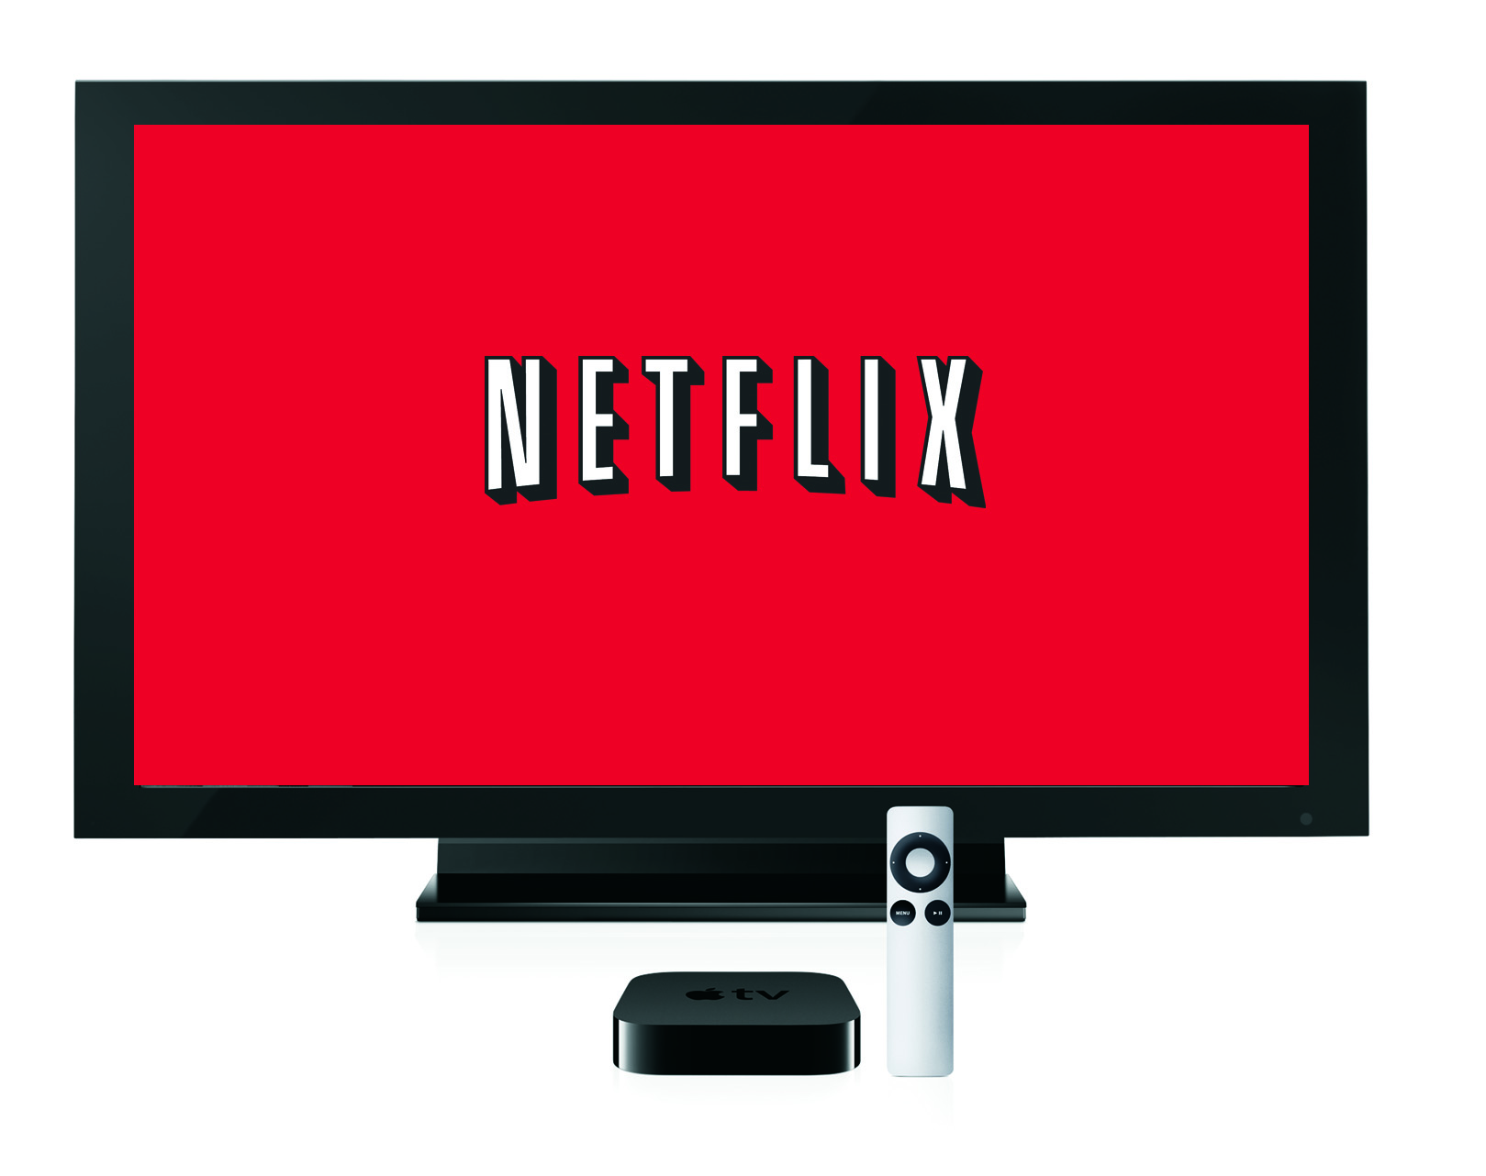
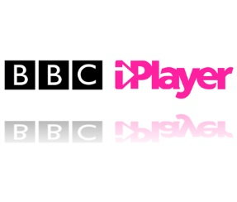
Often, digital media sectors do not exist independently. They often overlap and are connected. This is referred to as synergy.

Stages of Production:
- Someone has an idea.
- The idea must be developed.
  - Research must be conducted.
- The idea is pitched.
- The idea must be thoroughly planned before production.
- The product is created.
- The product is sold.
Stages of Production for a Film:
- Someone has an idea for a film.
- The idea must be developed.
  - Research must be conducted into other films of that genre, into the needs of the target audience, etc.
- The idea is pitched to a producer or film company.
- The idea must be thoroughly planned before production. This includes creating a script, a storyboard, getting actors, directors on board, etc.
- The product is created. This includes filming and editing of the raw footage.
- The product is sold; it will appear in cinema.
Now you try. Apply the above process to a GAME or a RADIO SHOW.
Someone has an idea for…

The idea must be developed by…

Research must be conducted into…

The idea is pitched to…

The idea must be thoroughly planned before production. This includes…

The product is created by…

The product is sold in…

- Immediacy: The speed at which audiences can consume digital media products.
- Access: The restrictions (or lack thereof) put on digital media products.
- Convenience: The ease at which a product can be accessed. This can include whether or not a digital media product is free, cheap, global, national, local, user friendly, etc.
- Portability: The flexibility and movement associated with a digital product (i.e. can the product be carried around with the user in their handbag, etc.?)
- Connectivity: The extent to which a product allows users to be linked to the ‘global village’, or to be part of a digital community, social network, virtual reality, etc.
- Interactivity: The ways in which producers/a product and a consumers work together. This includes the level of control the consumer has over the product, whether or not users can generate original content, the use of web-links, uploads/downloads, texting, e-mailing, or ‘red button’ functions to bring the consumer closer to the product.
- Personalisation: The ways in which the product can be made personal to the consumer. This could be done through logging/signing in, adapting interfaces, font features or music playlists.
Let’s consider the mobile phone:
Around the phone, write detailed annotations that explain how digital technology from a range of sectors is converged on your phone.
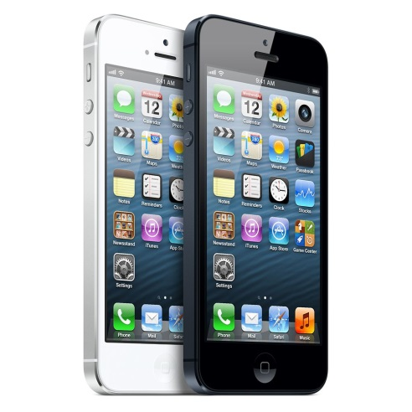

What are the advantages and
disadvantages of this convergence?

- Passive audience theory: When audiences directly receive and wholly accept ideas.
- Active audience theory: When audiences choose to consume a product to fulfil certain needs.
Passive: We blindly accept what we are given/told etc. | Active: We have a choice. We choose to consume a media text to fulfil our own needs.

- Individual consumption: When users engage with a digital media product on their own, for solo enjoyment (i.e. reader, gamer, consumer, web surfer, listener, DVD, viewer, social networking, etc.)
- Group consumption: When users engage with a digital media product with others, for collective enjoyment (i.e. social interaction, competition, belonging, sharing).
Hypodermic Needle Theory
- This was one of the first media theories used as an attempt to explain how audiences consume media. It suggests that the audience, passively (without realisation) receives information via media text and that they do not challenge or process the information.

Uses and Gratifications Theory
The Uses and Gratification Theory states that we are active consumers of media and that there are four main reasons we choose to consume any given media product:
- Need of Social Interaction
- Need for Education/Information
- Need for Identity
- Need for Entertainment

- Passive viewing: When an audience/viewer/consumer does not interact physic ally with the product or its content, does not generate content or influence the product.
- Active viewing: When an audience/viewer/consumer physically interacts with the product, to become part of the production. The audience has an element of control over how they interact with the product.
- Target audience: a specific group of people within the target market at which a product or the marketing message of a product is aimed at.
- Primary audience: The main target audience of a product.
- Secondary audience: Any consumers that are outside the primary target audience.

Audience Categories
- Age
- Gender
- Socio-economic background
- Personality type
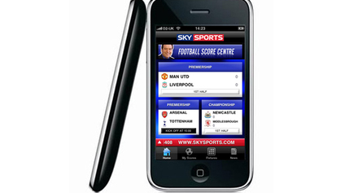
Who is the primary audience? Annotate:
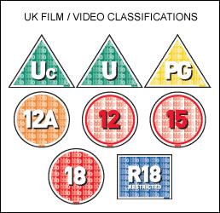
Regulatory Bodies
- BBFC: Regulates the film industry and classifies films.
- PEGI: Regulates the gaming industry and classified games.
- OFCOM: Regulates the communications industry.
- ASA: Regulates the advertising industry.
- PCC: Regulates the press industry.

Audience statistics: When facts and figures are collected on things like circulation, website ‘hits’, box office figures, ratings, sales, etc.
There are two basic types of research. They are:
- Primary research: research that is conducted first-hand (questionnaires, focus groups, interviews, etc.).
- Secondary research: ‘second-hand’ research conducted by using existing primary research information (books, magazines, internet, etc.)
Primary Research:
Questionnaires, surveys, interviews, focus groups, product analysis

Secondary Research:
Internet research, library research, archive research, reading, magazines

4
What are the benefits of each?

Research can then be broken down into the following:
- Qualitative research: measuring individual opinions, attitudes, behaviour and the psychology behind the choices people make
- Quantitative research: to measure responses in quantifiable terms (how much, how many), using numerical data
Questionnaire: a research instrument consisting of a series of questions and other prompts for the purpose of gathering information from respondents. Although they are often designed for statistical analysis of the responses, this is not always the case.
Open Questions:
- These questions allow the respondent to write their own response.
Closed Questions:
- These types of questions often have a ‘yes’ or ‘no’ response.
Data analysis: a process of inspecting, cleaning, transforming, and modelling data with the goal of highlighting useful information, suggesting conclusions, and supporting decision making.
Audience Profiles:
An audience profile is one way for producers to work out exactly who is buying their product, which helps them to ensure their product will sell. Several factors are considered, including:
  - Age - Education
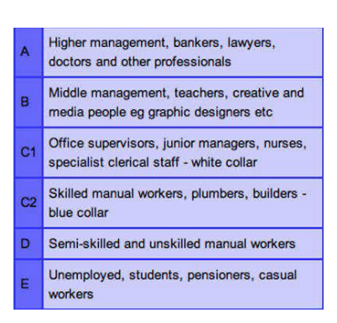
  - Gender - Occupation
  - Race - Income
  - Sexuality - Personality type
  - Lifestyle - Buying habits
Demographics: A particular sector of a population.

Denotation: a description or identification; what you can physically see.
Connotation: associations that the image or text implies or suggests.
- For example, in Britain, we associate the colour white with innocence, purity, weddings…
- While in China, white is the colour of mourning and is worn at funerals

Mise en scene: the use of costume, hair, make-up, props, setting and figure expressions.
- Use of colour; do they use contrasting colours, black and white, filters, saturation, shades, tones?
- Use of movement; does the camera pan, tilt, track, use slow motion, speed up, zoom in, zoom out?
- Framing and angles; long shot, close up, medium shot, etc.
Written Codes:
The study of written codes includes:
- Slogans
- Typeface/Font
- Headlines
- Captions
- Style
- Choice of words
- Emphasis of words
What do the following fonts connote/signify?
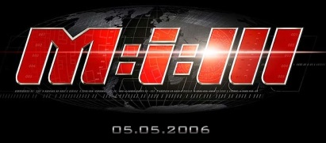

What do the stylistic codes in this advert connote/denote? Annotate. (Colour is gold)

